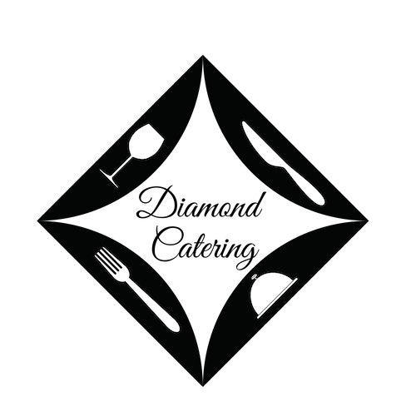
A la Carte Menu

Simply Brilliant!
315-487-0647
info@diamondcatering.com
diamondcatering.com

Full Order (20-25
Servings)

Half Order
(10-15
Servings)

Salads |  | Baby Bleu Salad ~ Mixed Greens, Blueberries, Pecans, Bleu Cheese and Sweet and Sour Blueberry Dressing | 45 | 80
 |  | Classic Caesar- Romaine, grated Asiago Cheese, Caesar Dressing, deep fried Croutons | 45 | 85
 |  | Lemon Zing Pasta Salad- Pasta, Lemon Zest, diced Vegetables, Vidalia Dressing | 42 | 80
 |  | Cole Slaw- Cabbage, Carrots, Pineapple, unforgettable Slaw Dressing | 42 | 80
 |  | Potato Salad- Red Skin Potatoes, | 42 | 80
 |  | ‘Cuse Cuke Salad- Tomato, Basil, Mozzarella and Cucumbers | 45 | 80
Sides |  | Split Rock Greens- Escarole, Pancetta, Cherry Peppers | 60 | 110
 |  | Baked Penne Siciliano- Artichoke Hearts, Imported Olives, Sun Dried Tomatoes | 45 | 85
 |  | Smoked Gouda Macaroni and Cheese- Shells, Gouda, Toasted Butter Crumb Topping | 55 | 95
 |  | Shells and Broccoli- Garlic Butter | 45 | 80
 |  | Traditional Baked Italian Pasta- Tomato Basil Marinara, Mozzarella | 45 | 80
 |  | Roasted Vegetables- Fresh seasonal garden Vegetables | 40 | 75
 |  | Rice Pilaf | 45 | 80
 |  | Salters- Upstate Salt Potatoes, Drawn Butter | 40 | 75
 |  | Herb Roasted Potatoes- Extra Virgin Olive Oil, Fresh and Dried Herbs | 40 | 75
 |  | Maple and Bacon Baked Beans- House cured Bacon, Vermont Maple Syrup | 40 | 75
Entrees |  | BBQ Chicken- Boneless, house BBQ Sauce | 45 | 85
 |  | Vidalia Chicken- Boneless, egg-battered breasts, Sweet Vidalia Onions | 45 | 85
 |  | Herb Roasted Chicken- Boneless, oil and herb rubbed | 45 | 85
 |  | Chicken Riggies- Rigatoni, Cherry Peppers, Fried boneless Chicken (spicy) | 60 | 120
 |  | Bourbon Beef Brisket- House smoked and sliced Brisket, Rich, dark Bourbon Sauce | 75 | 140
 |  | Eggplant Rollatini- Breaded Eggplant Cutlets, Fresh Ricotta, Tomato Basil Marinara | 50 | 90
 |  | Pulled Pork- House smoked Pork, house BBQ Sauce, Rolls | 65 | 120
 |  | Italian Meatballs- Scratch meatballs, Tomato Basil Marinara | 55 | 100
 |  | Sliced Prime Rib Au Jus |  | 235
 |  | SPO- Sausage, Peppers and Onions, house made Rolls | 50 | 85
 |  | Heavenly Thighs- Brown Sugar and Cinnamon-Spice Marinated boneless Chicken Thighs | 50 | 90
Extras |  | Chafing Racks |  | 20ea
 |  | Paper Products |  | 2.50pp
 |  | Soft Drinks or Bottled Water |  | 2pp
 |  | Delivery (within 10 miles- add $2.50 for each additional mile) |  | 25
 |  | Prices are subject to change without notice

